DA2010 Notes
2018 August 7

Has two main divisions; one for church books and one for other archives

Church Books - https://media.digitalarkivet.no/en/kb/browse

Bottom line for scanned church books – this site offers no discernable resources that are not available on the newest version of the Digital Archives (DA2017) and none are transcribed.

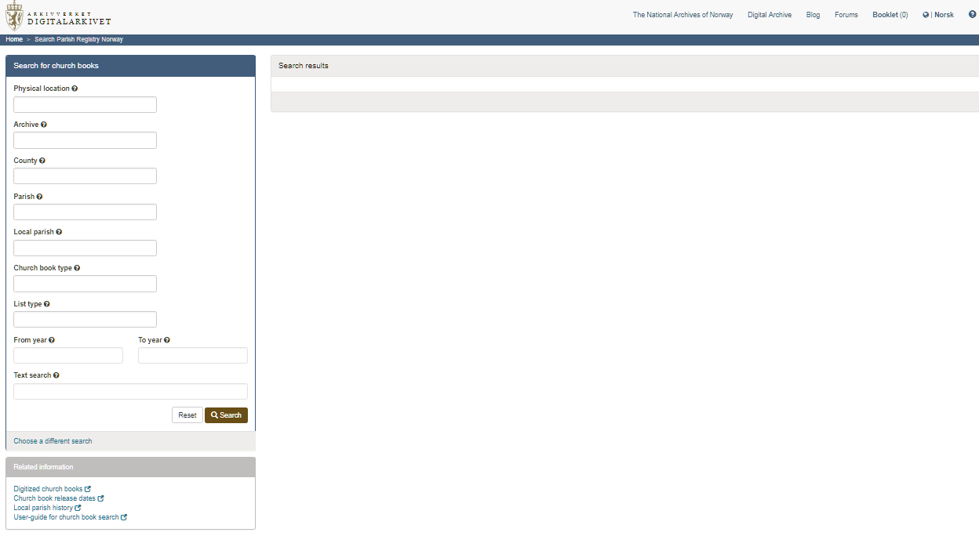

Categories

As shown in the box on the left, nine categories are given. Here are summaries of the main categories

Physical location – national, regional, local archives. Do not need to fill out.
NHOH examples include Regional Archives in Hamar. Had 1541 results

Archives –Again, don’t need to fill out.
NHOH examples include Elverum prestekontor, Furnes prestekontor, Ringsaker prestekontor
For Ringsaker prestekontor, 59 items are available. Mostly, these are parish registers up through 1973, but it includes 3 Banns registers and 1 birth register. For Ringsaker, the parish records are in three groups:

Draft: 1773-1814
Official: 1734-1922
Copy: 1814-1973

County – this does not need to be selected, but helps to limit choices.

Parish – They are listed alphabetically. For Hedmark fylke, 32 parishes are given.
A search for church records for Ringsaker produced the same 59 items as through the Archives category

Local Parish – don’t need to use previous two categories. Produced 47 results; did not include the local books for Veldre and Brøttum

Church book type – click in box to see choices

List type – click in box to see choices

Text search – I have not been able to figure out how to use this category.

Other Scanned Archives - https://media.digitalarkivet.no/en/db/browse

Bottom line – this site has lots of diverse resources, which truly dedicated researchers might want to visit. But for those looking for just names and dates, this resource is not appropriate.

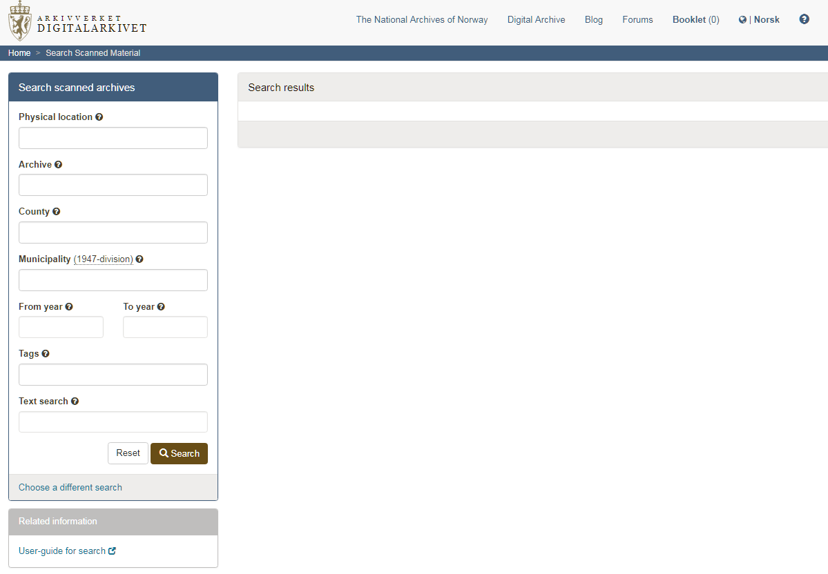

Categories

Physical location – national, regional, local archives. Do not need to fill out.
NHOH example includes Regional Archives in Hamar. Had 25 results, mainly fire class records for Hamar

Archives – Found none for Hedmark

County – Don’t need to fill out previous categories. For Hedmark, 633 results. Many are statistical analyses of populations in 1928-1960, along with dissent church records from 1903-1957; also included are government financial records, military records, and, W. Lassen’s collection. Some collections, such as land ownership maps, are not indexed.

Municipality – Don’t need to fill out previous categories. For Ringsaker, 307 results.

Tags – lots of interesting choices.

Text search – Again, I have not been able to figure out how to use this category.

