Notes on the DA2017 Internet Site
2018 August 7

This site is at https://www.digitalarkivet.no/en/ and is the most recent version of the Digital Archives web pages, having been activated in 2017.

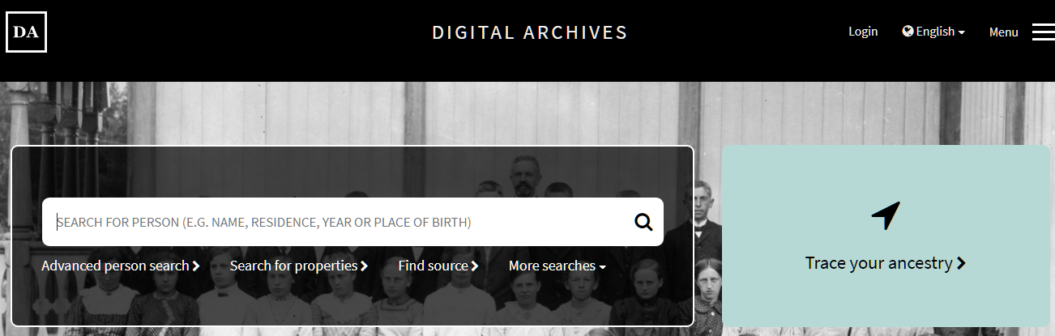

While it has an incredible amount of new data, it does not carry over all the data from the previous versions of the site, nor does it have all the censuses that the RHD site has.

For example, the GDA site has databases of transcribed out-migration records for a number of communities, while this site does have these databases. And, the RHD site has nearly 420 full censuses for 1875, while this site has only 255.

But the biggest lack for many researchers is that the GDA site makes it easy to see fellow passengers on emigration ships from the ports of Norway, while this site requires a two step process.

For many other uses, however, this site has much more power than other sites. Unfortunately, there is not a comprehensive guide for the use of the site – although there are some excellent guides on some details – so experimentation is required.

First, direct your attention to the upper right hand corner where it reads ‘Menu’. Click on it to bring up the next screen:

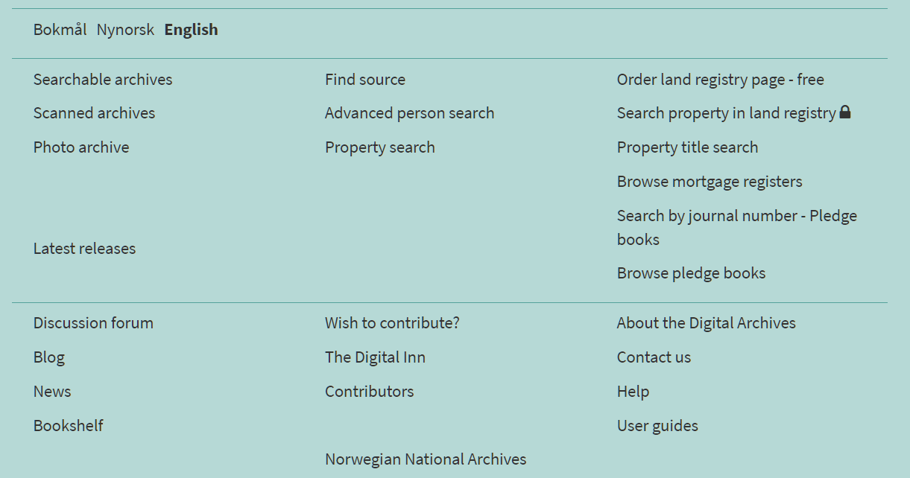

Clicking on the ‘Help’ link brings up the following screen:

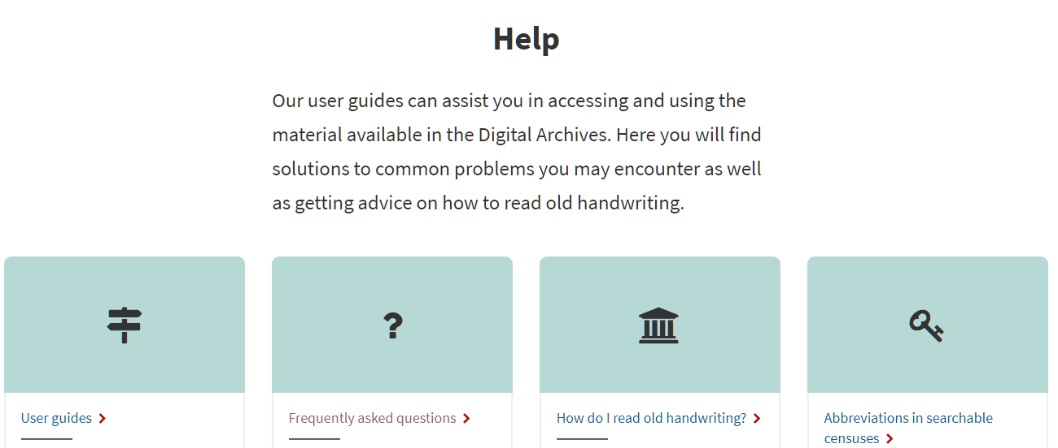

I highly recommend going through each of these before using the site. (I especially like the ‘or’ symbol - |.)

The Find Source option
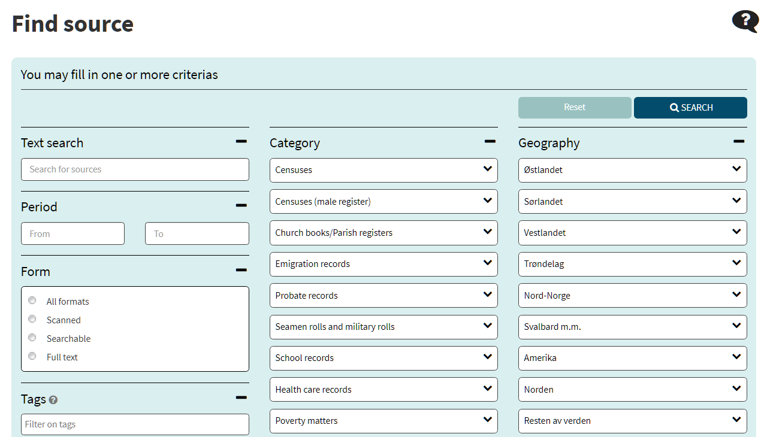
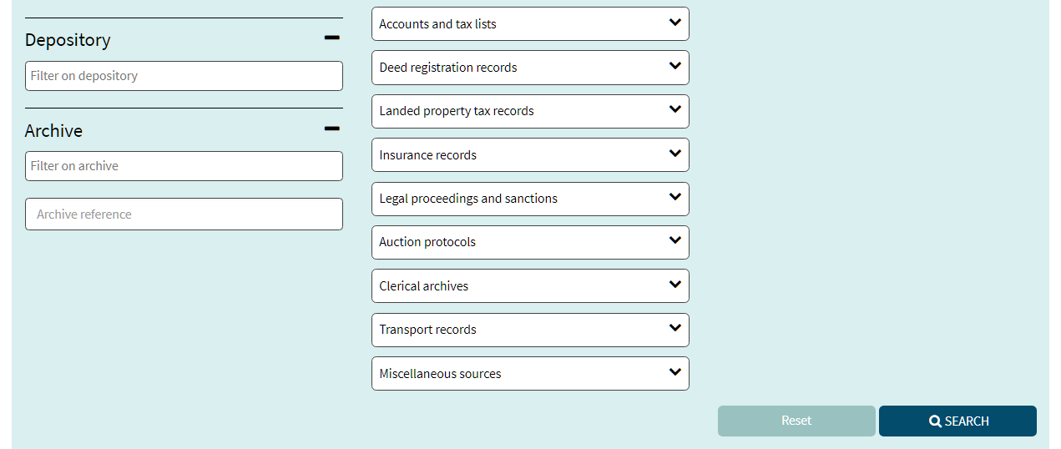
According to information on the site, this is the method by which the majority of information is accessed. The amount of data available is almost over-whelming, with 18 categories of data. As a comparison, for Ringsaker, some 700 databases are available, versus the 32 which were found on the GDA site and the 366 on the DA 2010 site.

Obviously, we can’t go over all categories in a single workshop, so, again, experimentation is needed. But, since most people will limit themselves initially to church and census records, let’s look at the church records as an example.

Start by putting in the dates of the period that you want to search in the boxes on the left. For many records, I recommend selecting a few years before and a few years after the assumed or believed date. Then, click on the box that reads ‘Church books/Parish records’ and click on either ‘Select all’ or the category that you want. Next, go to the right hand side of the page and select the region of the country, and find the fylke or county of interest. For an example, I am going to look for the birth on Henrik Jensen, who I believe was born in either Romedal or Ringsaker in Hedmark fylke around 1858. The form looks like the below when it is ready to be searched; see the top left hand side of the form for the type of records chosen and the geographical areas selected.

(Note that there is no user guide for which fylke are in which geographical region. This is part of the experimentation.)

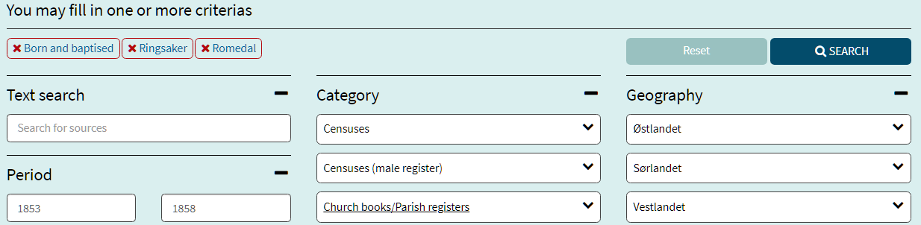

After clicking on the ‘Search’ button, eight possible church books are presented. Note that in some cases, the records are searchable.
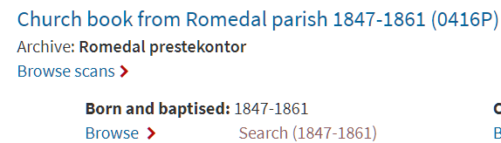

Filling out the form below for the search of these birth records for the first name of ‘Henrik’ and the role of ‘barn’ (child), we find just 10 births. Several are outside the time frame, several have Henrik as the middle name, and the remainder has the incorrect father. We then go to the Ringsaker list and there is one person, who happens to be the right person!

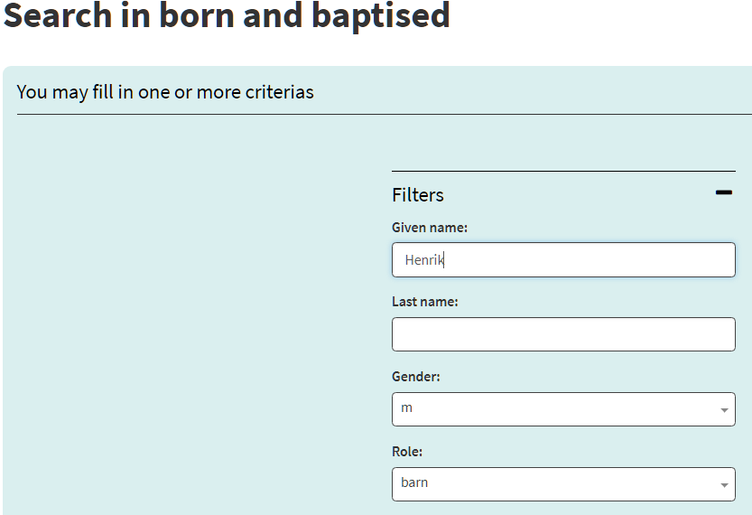
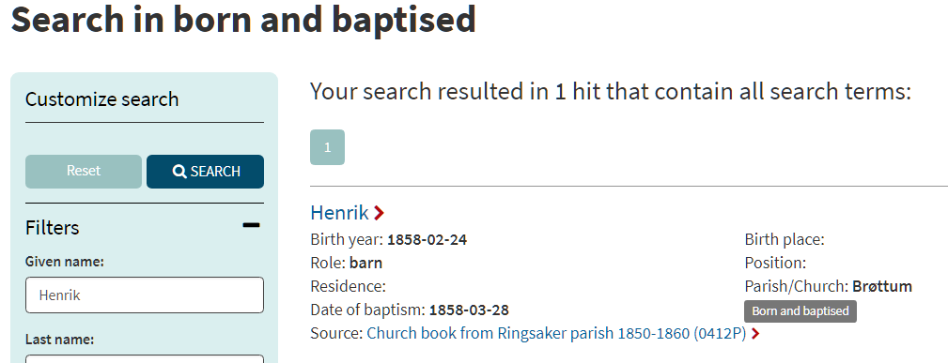

Note: Birth records typically do not have a last name for the child – adding one to the search form would then result in no results.

The More Searches option

In the ‘Find source’ option above, the search for Henrik in two parishes resulted in being presented the books for each parish, and it is necessary to go through the books until the right one is found.

The ‘More searches’ option has a different approach. Again, we will search for Henrik Jensen’s birth record between 1855 and 1865 in the Ringsaker and Romedal parishes. Clicking on the link brings up a drop-down box:

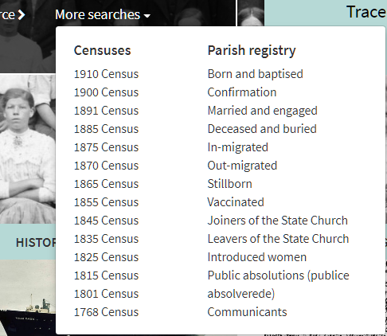

We choose the ‘Born and baptised’ option and get:

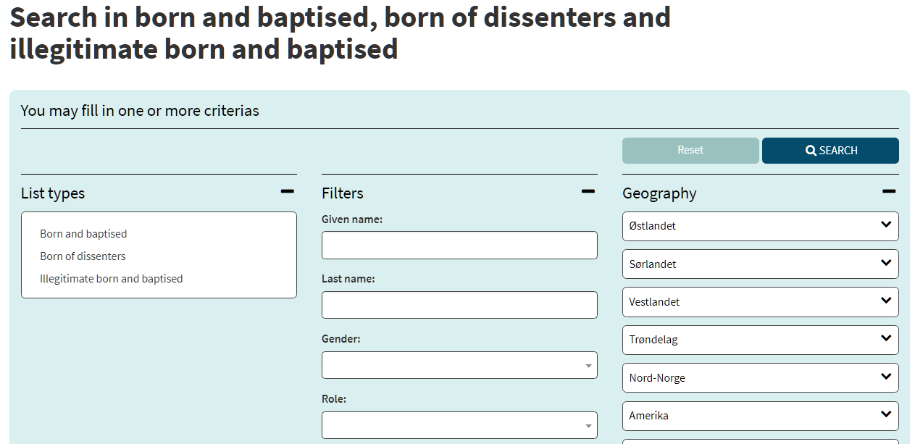

Again, the given name is Henrik and the role is barn, but when we go to Geography and select Hedmark fylke under Østlandet, there is a surprise! Instead of the list of 32 parishes in alphabetical order in the ‘Find source’ option and earlier DA sites, we now have 48 parishes in numeric order! This is the first part of the list:

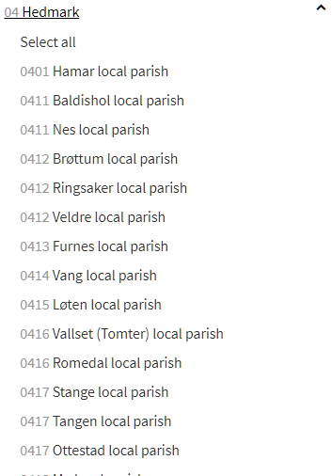

But, not to panic. The list has the local parishes rather than the main parishes, and the numbers correspond to the main parish. So for Ringsaker – which is parish 0412 – we also want Brøttum and Veldre, unless we know for sure to eliminate one or more local parishes. And, for Romedal (0416), we want to include Vallset (Tomter). Thus, our search form will appear as follows, with the chosen parishes items at the top. Note that I also added a date limiter of 185*|186* as a starting point. This limited the records to years starting with 185 or with 186:

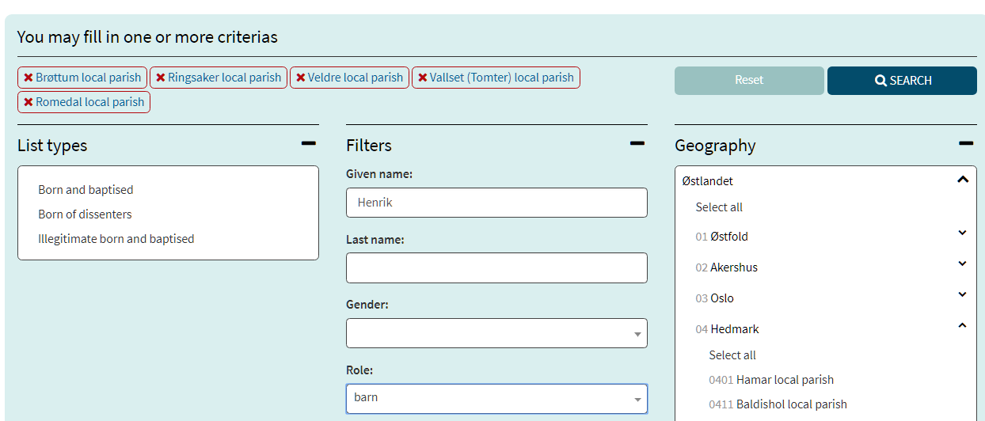

This search found 10 boys born in these areas with this name. Two were from Ringsaker and Brøttum, with one of those from 1869 and thus not in our range, and the other was our person. There were also 8 from Romedal.

While this is a somewhat trivial example, it shows the power of this system. There are 28 categories of records from the drop-down box and in the geography section, any combination of fylke and parishes can be chosen, similar to the RHD site.

Emigration group records

Now let’s go back to the biggest drawback that some genealogists find with this site – the lack of the nice passenger list for emigrations such as provided on the GDA site.

In the section on the Gamel DA, the challenge was:

For example, a recent search was for Gustav/Gustave Nelson/Nilsen/Nielsen, who was
said to have emigrated in 1885. Given that he emigrated either from Hedmark (Ringsaker)
or perhaps Oppland (Biri or Land), the search was done in the lists of Oslo/Kristiania.
In the database of ‘Emigrants from Oslo 1867-1930 old ‘

Using ‘Find source’, we select ‘Oslo’ and ‘Emigration records’

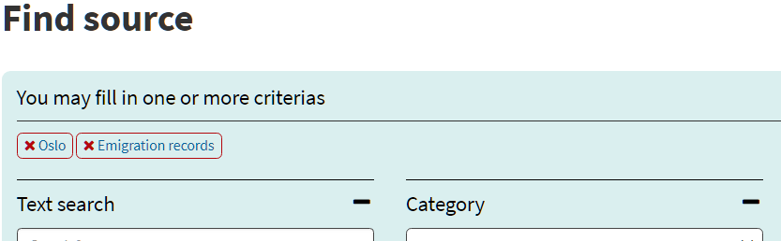

and get 20 choices, of which the top three are:

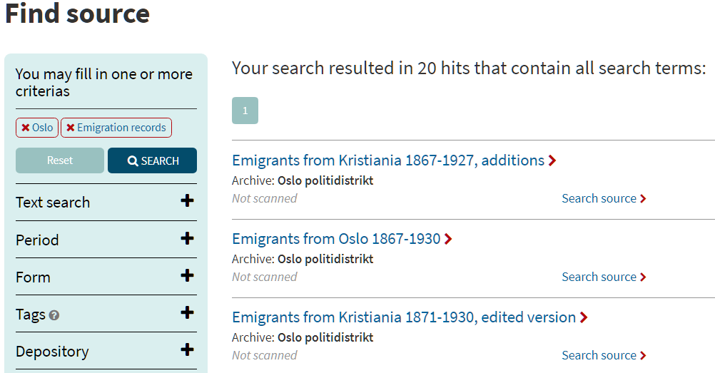

We click on ‘Search source’ for ‘Emigrants from Oslo 1867-1930’ as we did on GDA, and fill out the form, now being able to use ‘or’ commands for the first and last names:

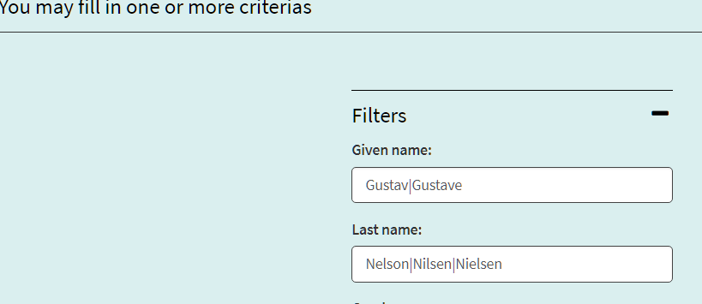

and, we get two choices:

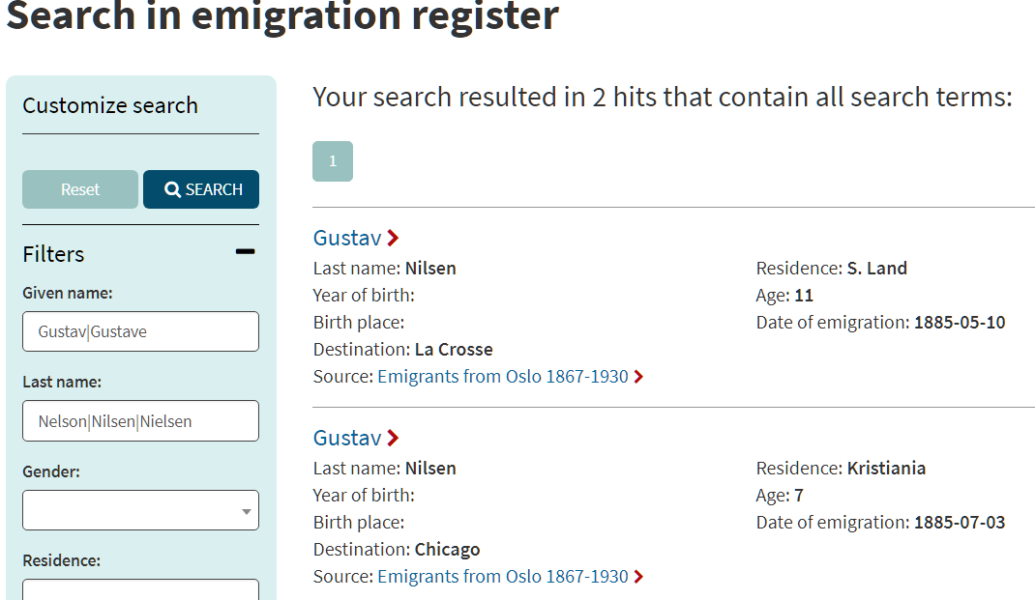

Choosing the first (since we knew that he did not come from Kristiania, but possibly from S. Land), we then get:

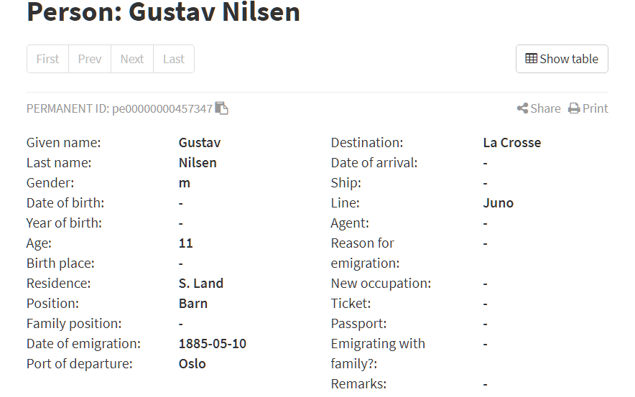

We can now go back to the search form, take out all names and look for people who traveled on the same date from the same residence and/or were going to the same destination. Doing this, we find a young women by the name of Karen M. Nilsen, and assume that it is his sister. For further comfort, we note that the records of Gustav and Karen M. have ID and serial numbers which differ by one between the two people.

While this is not as clean of an approach as with the GDA site, it is a work around.

Obviously, the DA2017 site has many other search capabilities that we don’t have time to do in this workshop. For example, test a search for Henrik Jensen in the ‘Advanced person search’ – you might decide to only use this search function !

In closing

It must be recognized that all the sites we have gone over in this workshop can have errors and omissions. Also, these are secondary sources, and, to be sure, the primary sources should always be found.

