Gamle Digital Archive Site Notes
2018 August 7

Web site is http://gda.arkivverket.no/cgi-win/WebMeta.exe?spraak=e

Bottom line is that this site has some unique databases, and the biggest advantage to many people is its ability to show fellow passengers leaving the ports of Norway.

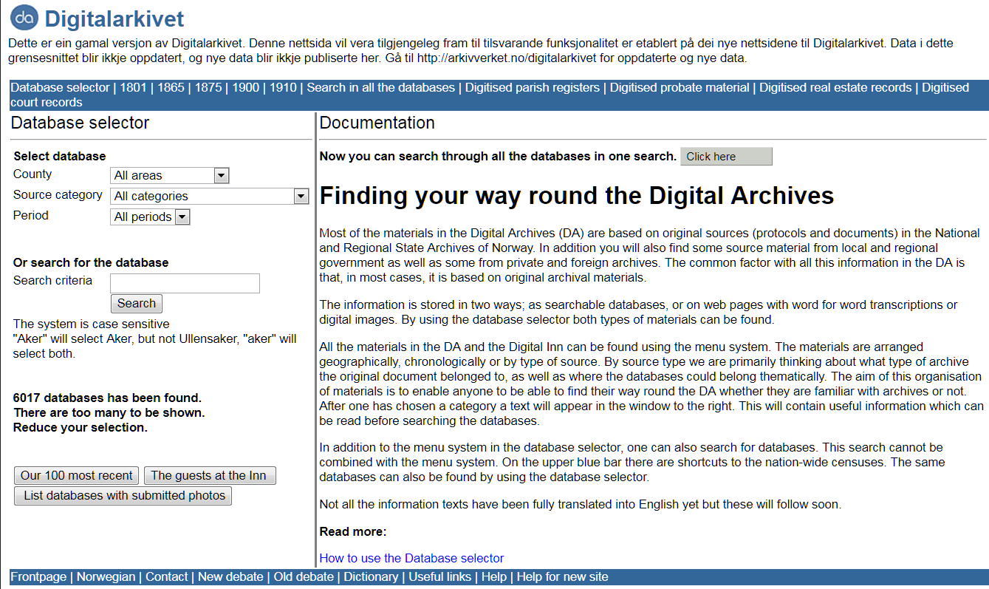

As shown above, this site has some 6000 databases, some of which were not carried over to the newer DA sites. The most recent databases on this site are from the end of 2011.

The site has 17 categories of materials; on the English version, they are sometimes listed in both English and Norwegian. But, the list is not uniformly presented for all categories, and in some cases, only the Norwegian version is shown. The 17 categories are:

English | Norwegian
Censuses | Folketeljingar og manntal
Church registers | Kyrkjebøker
Citizenship | Borgarruller
Clerical archives | Geistlege arkiv
Deed registration and severance | Tinglysing og jordskifte
Emigrants | Emigrantar
Fire assessment registers | Branntakstprokollar
Health care | Helseføretak
Landed property tax protocols | Matriklar og jordebøker
Legal procedure | Rettargang og straff
Maps | Kart
Military | Militærvesen
Paupers | Fattigstell
Probate registers | Skifte
School | Skule
Tax lists | Skattelister
Other | Andre

The dropdown boxes on the left are self-explanatory. Once a county is selected, a new category of municipality is given.

The municipalities are presented by municipal number, and not in alphabetical order. In Hedmark fylke, there are 32 municipalities given.

Looking just at Ringsaker (0412), there are 32 databases:

5 census databases
3 church registers
2 emigrant registers
2 probate registers
10 journals of court records
1 church account database
3 landed property tax protocols
4 deed and mortgage registers
2 miscellaneous databases

In some cases, the databases here are not found on any other site. For example, one of the censuses is from 1660, and one of the church registers is ‘Out-migrants from Ringsaker 1814-1925’ and another is ‘Civil weddings in Hedmark and Oppland 1856-1920’.

Note that although the top dark blue line has links to digitized parish registers, probate material and real estate records, these links are actually to a different site – the Digital Archives 2010 site, also known as DA2010.

But perhaps the most important feature of the GDA site is ability of the emigrant databases of Oslo and other ports to show not only the person of interest, but other people listed before and after on the register.

For example, a recent search was for Gustav/Gustave Nelson/Nilsen/Nielsen, who was said to have emigrated in 1885. Given that he emigrated either from Hedmark (Ringsaker) or perhaps Oppland (Biri or Land), the search was done in the lists of Oslo/Kristiania. In the database of ‘Emigrants from Oslo 1867-1930 old’ , we got the following, after going through the variations of the choices of first and last names:

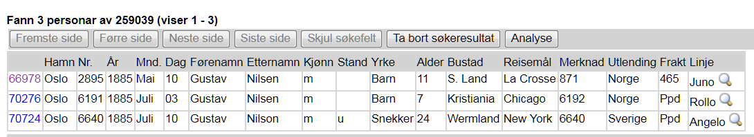

Clicking on the number at the far left for the first entry – since we know that he is potentially from S. Land – we get this:

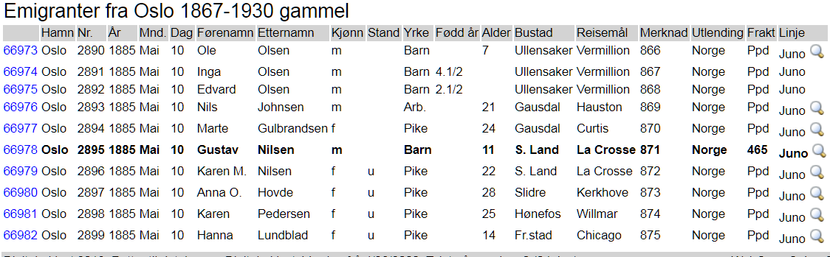

and it appears that yes, a sister by the name of Karen M. traveled with him. (We were later able to find her records as well as his.)

No other site that I am aware of has this feature to show fellow travelers in such a clear, concise and comprehensive manner.

