Notes on the RHD Census Web page
2018 August 7

Bottom line: This site has the easiest and most comprehensive set of census databases, including many (about 420) for 1875.

Web page is http://rhd.uit.no/indexeng.html

Known as the Registreringssentral for Historiske Data, it is also known as the Norwegian Historical Data Centre (NHDC)

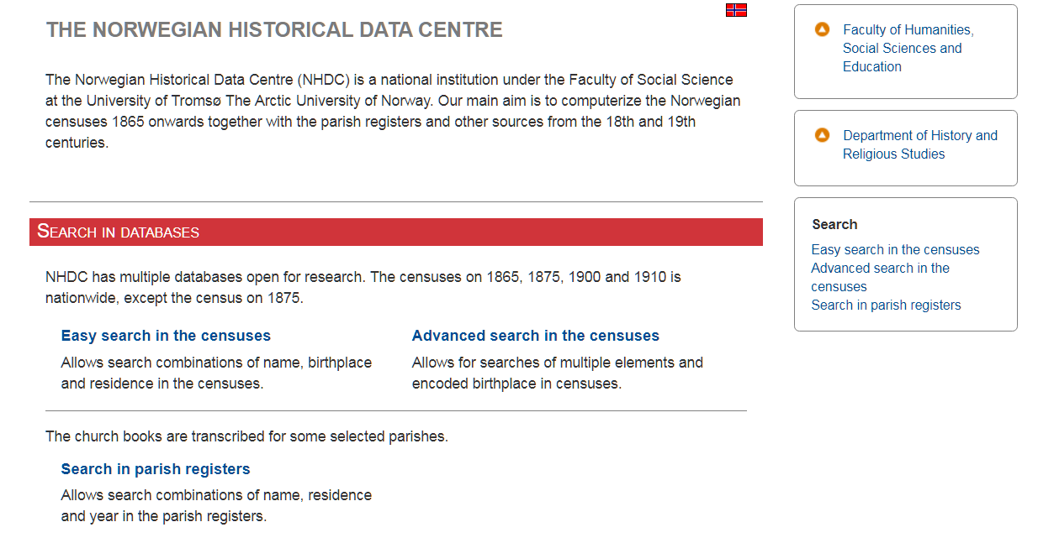

Although it does have other databases, the vast majority are census records. For example, it can search parish records, but that ability is limited and somewhat cumbersome. It is limited to 81 communities and the list is in no discernible order. For the Nord Hedmark area, only 4 communities have searchable parish registers, and only for limited years – Engerdal’s records, for example, cover only 1898-1910.

Similarly, there are records for the silver tax of 1816 and the 1838 matrikkelen for some parts of Norway, and a small probate register for a few areas of the country.

The focus of the site are the censuses for 1801, 1865, 1875, 1900 and 1910, along with the matrikkelen of 1886, with some censuses of 1885 and 1891.

The site provides both a simple search engine and an advanced search engine for the censuses. The 1801 census is only accessible with the advanced search engine. A link to instructions is provided on both the simple and advanced data entry forms and the instructions are very useful.

In both the simple and the advanced search engine, the search can focus on any number of fylke and communities within the fylker. The communities are listed in alphabetical order and the number varies by census year. For Hedmark, the 1801 census lists 17 communities, the 1865 census has 25 communities, the 1875 census has 26, while the 1900 and 1910 censuses each have 29 communities. Note that the Gamel and 2010 Digital Archive sites each list 32 communities for Hedmark; those sites use the 1947 boundaries.

The simple search allows the entering of any or all of first name, last name, birth place and place of residence. No wild card is needed if only a partial form of the search word is used (1 letters is sufficient). The wild card asterisk (*) is not allowed, but ‘%’ can be used. For example, to search for Jens Larsen, who was born in a community which begins with ‘So’, type ‘Jen’ in the first name box, ‘Lars’ in the surname box and ‘So’ in the birth place box and check any fylke or no fylke.

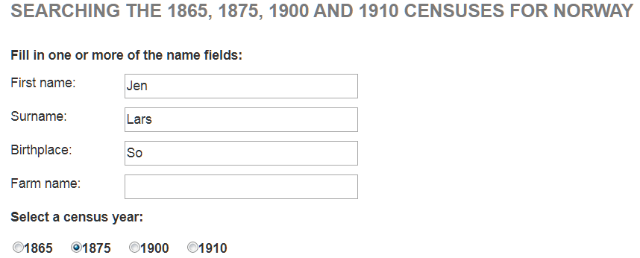

The advanced search form allows for the use of up to eight criteria and includes the 1801 census. Unlike the simple search form, wild cards are necessary if the entire word is not spelled out and both the ‘*’ and the ‘%’ sign work as wild cards.

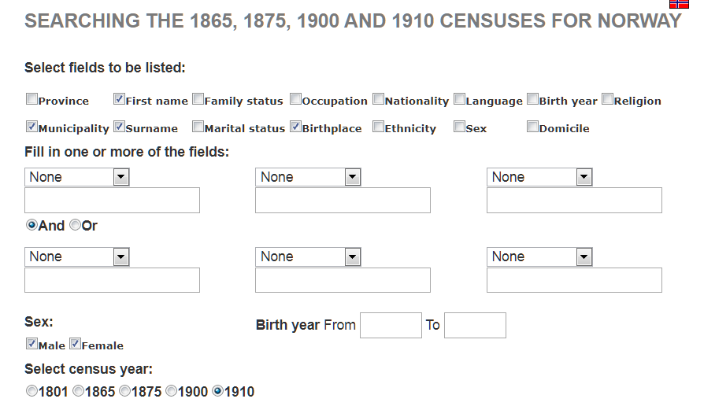

In both search systems, in the results, a small house icon at the far left allows the user to click to see the entire family. On the page with the entire family, there might also be another symbol before the name of a family member and this links to information in other records. This is an incredible resource where it exists – in one search, for example, the father was linked to 12 other records.

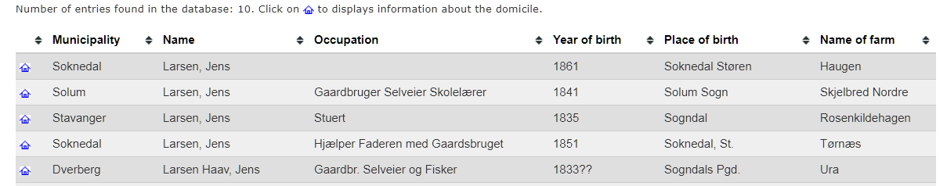

The census results also allow the user to see who is living on the previous and following households in the census records.
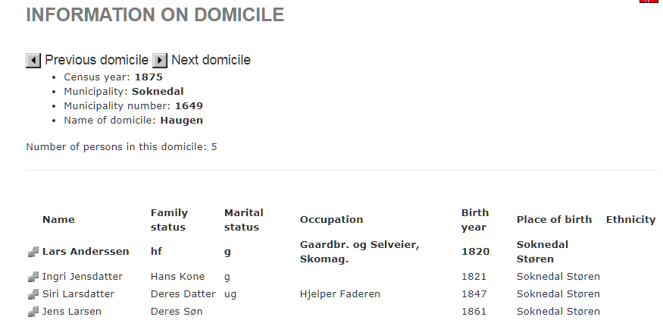

One of the special features of the RHD site is that it has more censuses from 1875 than any other site, and has a table of which communities have these censuses, along with the censuses for 1865, 1900 and 1910.

For example, for Hedmark fylke, the RHD site has 26 searchable full censuses for 1875. The next best site that I am aware of is the most recent Digital Archives site (DA2017), which has only 8 searchable 1875 censuses for Hedmark fylke.

(There is a link on the RHD site to the old search page. I do not recommend going there, as the results will be based on old data. )

