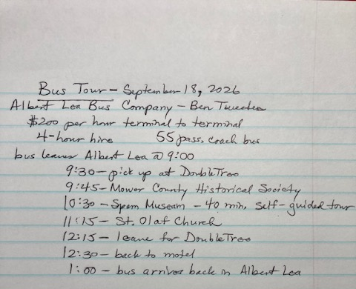
Time between locations may be less10 minutes, according to Google Maps. I used 10 minutes between stops but show the google map times so you can see the estimated time that could help account for getting on and off the bus.
9:30 Leave hotel – 7 minutes to 1st stop
9:40 Mower County (45-minute tour)
10:25 Leave for Spam Museum– 6 minutes to 2nd stop (I put in 10 on next line)
10:35 Spam Museum tour (45 minutes)
11:20 Leave for church – 6 minutes to 3rd stop
11:30 Tour and lunch at St. Olaf (50 minutes)
12:20 Leave for DoubleTree – 4 minutes to hotel

